SQL Aliases

🌟 Definition
# Source: AI Source: Provided by: [Data Path: Persons Table -> ID Column: 1, Name_En Column: Motasem Essam] -> From: [ChatGPT] on [6/11/2026]
SQL Aliases are temporary names given to columns or tables in a SQL query to make the output easier to read and the query easier to write.
Aliases exist only during the execution of the query and do not permanently change the database.

🎯 Purpose
# Source: AI Source: Provided by: [Data Path: Persons Table -> ID Column: 1, Name_En Column: Motasem Essam] -> From: [ChatGPT] on [6/11/2026]
SQL Aliases are used to:
- Rename columns in the output
- Rename tables for shorter queries
- Improve query readability
- Simplify complex SQL statements
- Make report headings more meaningful

🧠 Simple Example
# Source: AI Source: Provided by: [Data Path: Persons Table -> ID Column: 1, Name_En Column: Motasem Essam] -> From: [ChatGPT] on [6/11/2026]
Employees Table
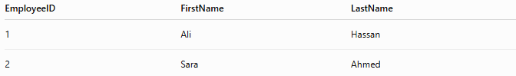
EmployeeID | FirstName | LastName
1 | Ali | Hassan
2 | Sara | Ahmed

SQL Statement
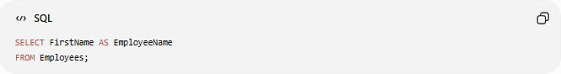
SELECT FirstName AS EmployeeName
FROM Employees;

Result
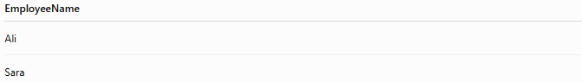
EmployeeName
Ali
Sara
The column FirstName is displayed as EmployeeName.

📝 Syntax
# Source: AI Source: Provided by: [Data Path: Persons Table -> ID Column: 1, Name_En Column: Motasem Essam] -> From: [ChatGPT] on [6/11/2026]
Column Alias
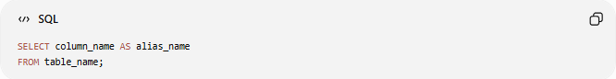
SELECT column_name AS alias_name
FROM table_name;
The keyword AS is optional.

Without AS
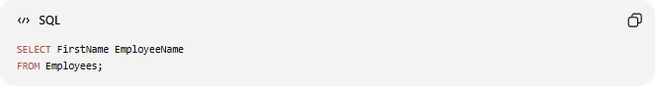
SELECT FirstName EmployeeName
FROM Employees;
Produces the same result.

Table Alias
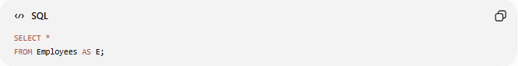
SELECT *
FROM Employees AS E;
Employees is temporarily renamed to E.

📚 Types of SQL Aliases
# Source: AI Source: Provided by: [Data Path: Persons Table -> ID Column: 1, Name_En Column: Motasem Essam] -> From: [ChatGPT] on [6/11/2026]

Type | Description
Column Alias | Gives a temporary name to a column
Table Alias | Gives a temporary name to a table

1️⃣ Column Alias
# Source: AI Source: Provided by: [Data Path: Persons Table -> ID Column: 1, Name_En Column: Motasem Essam] -> From: [ChatGPT] on [6/11/2026]
Rename a column in the result.
Example
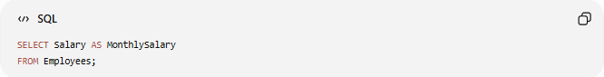
SELECT Salary AS MonthlySalary
FROM Employees;

Result

MonthlySalary
5000
6000
7000

2️⃣ Table Alias
# Source: AI Source: Provided by: [Data Path: Persons Table -> ID Column: 1, Name_En Column: Motasem Essam] -> From: [ChatGPT] on [6/11/2026]
Rename a table for shorter queries.
Example
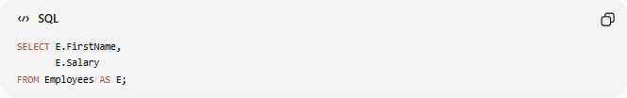
SELECT E.FirstName,
E.Salary
FROM Employees AS E;

The alias E replaces the full table name.

📚 Example: Multiple Column Aliases
# Source: AI Source: Provided by: [Data Path: Persons Table -> ID Column: 1, Name_En Column: Motasem Essam] -> From: [ChatGPT] on [6/11/2026]
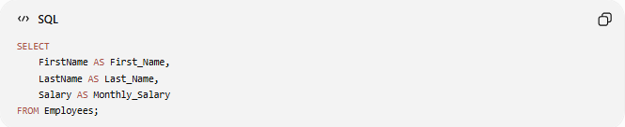
SELECT
FirstName AS First_Name,
LastName AS Last_Name,
Salary AS Monthly_Salary
FROM Employees;

Result
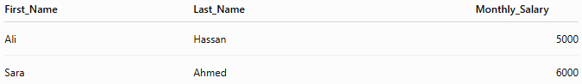
First_Name | Last_Name | Monthly_Salary
Ali | Hassan | 5000
Sara | Ahmed | 6000

📚 Example: Alias with Expressions
# Source: AI Source: Provided by: [Data Path: Persons Table -> ID Column: 1, Name_En Column: Motasem Essam] -> From: [ChatGPT] on [6/11/2026]
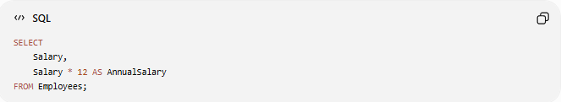
SELECT
Salary,
Salary * 12 AS AnnualSalary
FROM Employees;

Result

Salary | AnnualSalary
5000 | 60000
6000 | 72000

📚 Example: Alias with CONCAT
# Source: AI Source: Provided by: [Data Path: Persons Table -> ID Column: 1, Name_En Column: Motasem Essam] -> From: [ChatGPT] on [6/11/2026]
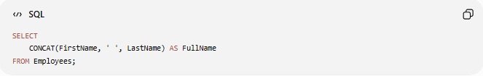
SELECT
CONCAT(FirstName, ' ', LastName) AS FullName
FROM Employees;

Result
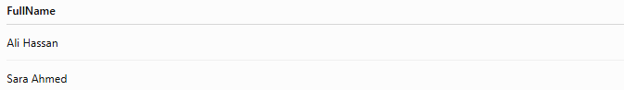
FullName
Ali Hassan
Sara Ahmed

📚 Example: Table Alias with JOIN
# Source: AI Source: Provided by: [Data Path: Persons Table -> ID Column: 1, Name_En Column: Motasem Essam] -> From: [ChatGPT] on [6/11/2026]
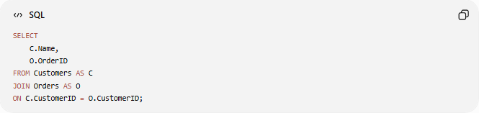
SELECT
C.Name,
O.OrderID
FROM Customers AS C
JOIN Orders AS O
ON C.CustomerID = O.CustomerID;

Result
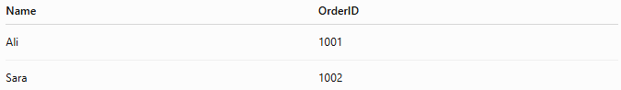
Name | OrderID
Ali | 1001
Sara | 1002
Without aliases, the query would be longer and harder to read.

📚 Example: Alias with Aggregate Functions
# Source: AI Source: Provided by: [Data Path: Persons Table -> ID Column: 1, Name_En Column: Motasem Essam] -> From: [ChatGPT] on [6/11/2026]
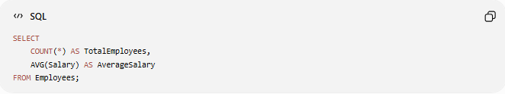
SELECT
COUNT(*) AS TotalEmployees,
AVG(Salary) AS AverageSalary
FROM Employees;

Result
TotalEmployees | AverageSalary
4 | 6500

📚 Example: Alias with ORDER BY
# Source: AI Source: Provided by: [Data Path: Persons Table -> ID Column: 1, Name_En Column: Motasem Essam] -> From: [ChatGPT] on [6/11/2026]
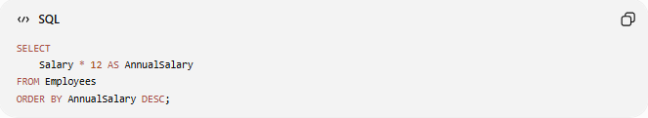
SELECT
Salary * 12 AS AnnualSalary
FROM Employees
ORDER BY AnnualSalary DESC;
You can use the alias in the ORDER BY clause.

🛠️ Complete Test Example

1️⃣ Create Table
# Source: AI Source: Provided by: [Data Path: Persons Table -> ID Column: 1, Name_En Column: Motasem Essam] -> From: [ChatGPT] on [6/11/2026]
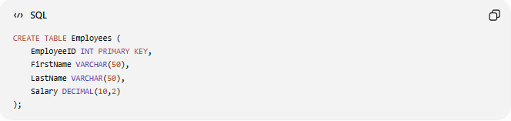
CREATE TABLE Employees (
EmployeeID INT PRIMARY KEY,
FirstName VARCHAR(50),
LastName VARCHAR(50),
Salary DECIMAL(10,2)
);

2️⃣ Insert Sample Data
# Source: AI Source: Provided by: [Data Path: Persons Table -> ID Column: 1, Name_En Column: Motasem Essam] -> From: [ChatGPT] on [6/11/2026]
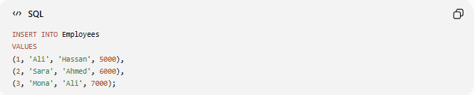
INSERT INTO Employees
VALUES
(1, 'Ali', 'Hassan', 5000),
(2, 'Sara', 'Ahmed', 6000),
(3, 'Mona', 'Ali', 7000);

3️⃣ Column Alias
# Source: AI Source: Provided by: [Data Path: Persons Table -> ID Column: 1, Name_En Column: Motasem Essam] -> From: [ChatGPT] on [6/11/2026]
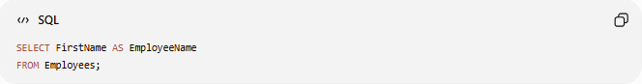
SELECT FirstName AS EmployeeName
FROM Employees;

4️⃣ Expression Alias
# Source: AI Source: Provided by: [Data Path: Persons Table -> ID Column: 1, Name_En Column: Motasem Essam] -> From: [ChatGPT] on [6/11/2026]
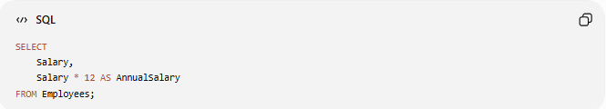
SELECT
Salary,
Salary * 12 AS AnnualSalary
FROM Employees;

5️⃣ Table Alias
# Source: AI Source: Provided by: [Data Path: Persons Table -> ID Column: 1, Name_En Column: Motasem Essam] -> From: [ChatGPT] on [6/11/2026]
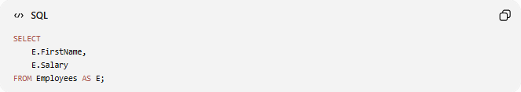
SELECT
E.FirstName,
E.Salary
FROM Employees AS E;

6️⃣ Aggregate Alias
# Source: AI Source: Provided by: [Data Path: Persons Table -> ID Column: 1, Name_En Column: Motasem Essam] -> From: [ChatGPT] on [6/11/2026]
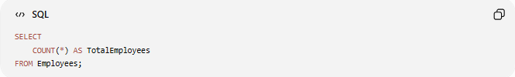
SELECT
COUNT(*) AS TotalEmployees
FROM Employees;

Real Example

prepared commands

1️⃣ Create Table
# Source: ScreenShot Source: Provided by: [Persons Table -> ID Column: 1, Name_En Column: Motasem Essam] -> Tool: [Automation Table -> ID Column: 16, Name_En Column: Screen Capture] -> From [Operating System: Wampserver64 -> phpmyadmin] on [6/11/2026]
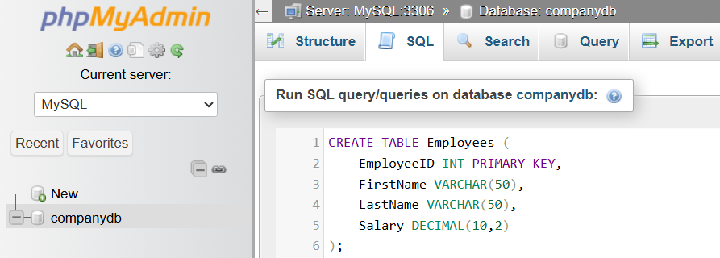
CREATE TABLE Employees (
EmployeeID INT PRIMARY KEY,
FirstName VARCHAR(50),
LastName VARCHAR(50),
Salary DECIMAL(10,2)
);
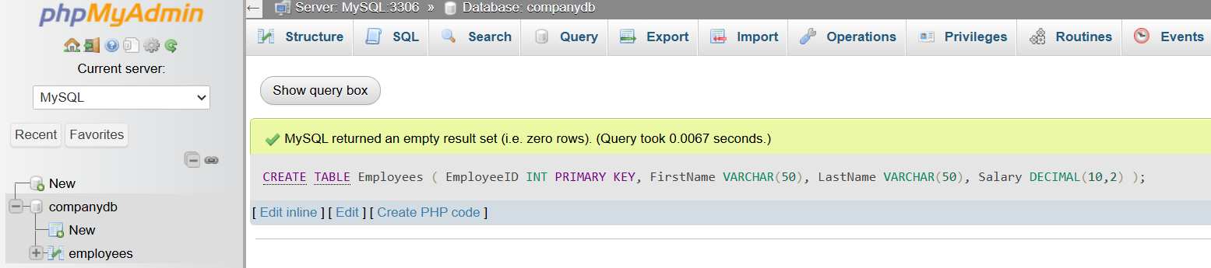

2️⃣ Insert Sample Data
# Source: ScreenShot Source: Provided by: [Persons Table -> ID Column: 1, Name_En Column: Motasem Essam] -> Tool: [Automation Table -> ID Column: 16, Name_En Column: Screen Capture] -> From [Operating System: Wampserver64 -> phpmyadmin] on [6/11/2026]
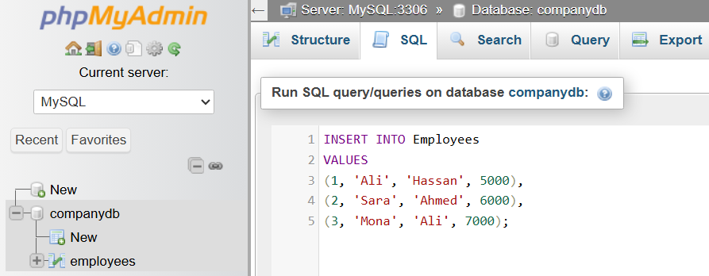
INSERT INTO Employees
VALUES
(1, 'Ali', 'Hassan', 5000),
(2, 'Sara', 'Ahmed', 6000),
(3, 'Mona', 'Ali', 7000);
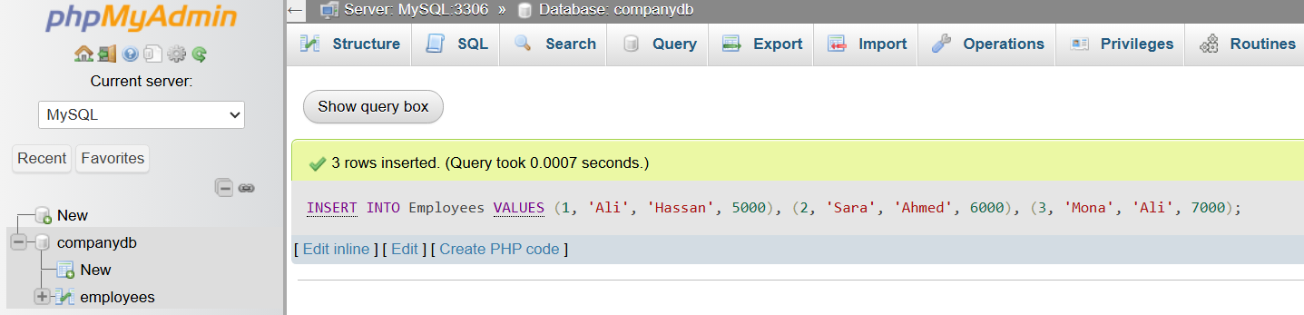

basic command

3️⃣ Column Alias
# Source: ScreenShot Source: Provided by: [Persons Table -> ID Column: 1, Name_En Column: Motasem Essam] -> Tool: [Automation Table -> ID Column: 16, Name_En Column: Screen Capture] -> From [Operating System: Wampserver64 -> phpmyadmin] on [6/11/2026]
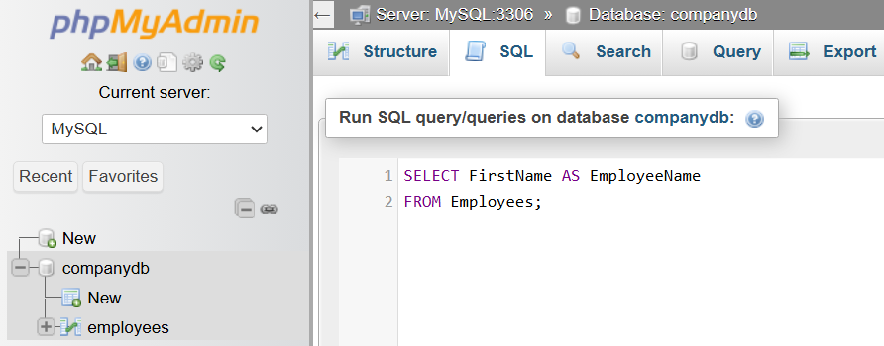
SELECT FirstName AS EmployeeName
FROM Employees;
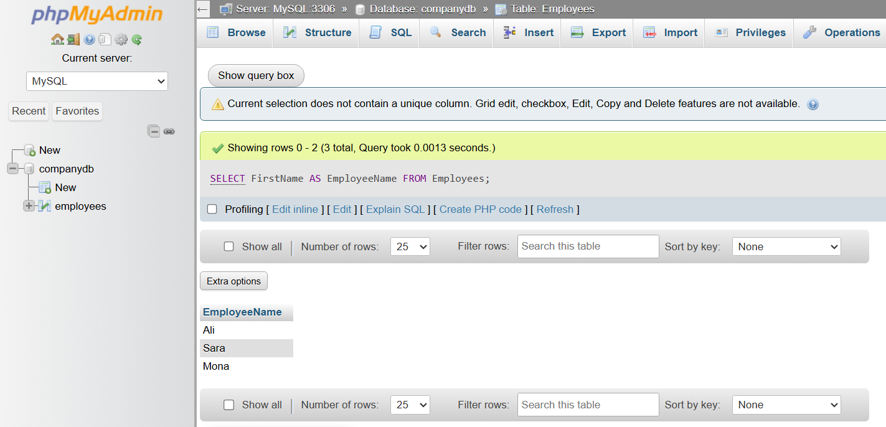

4️⃣ Expression Alias
# Source: ScreenShot Source: Provided by: [Persons Table -> ID Column: 1, Name_En Column: Motasem Essam] -> Tool: [Automation Table -> ID Column: 16, Name_En Column: Screen Capture] -> From [Operating System: Wampserver64 -> phpmyadmin] on [6/11/2026]
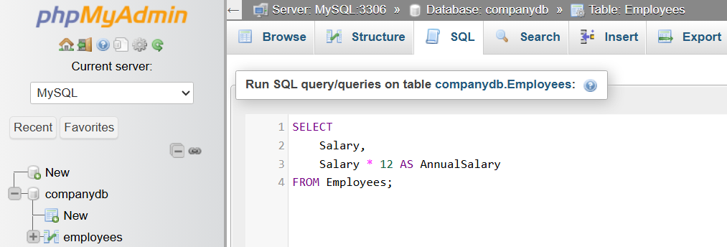
SELECT
Salary,
Salary * 12 AS AnnualSalary
FROM Employees;
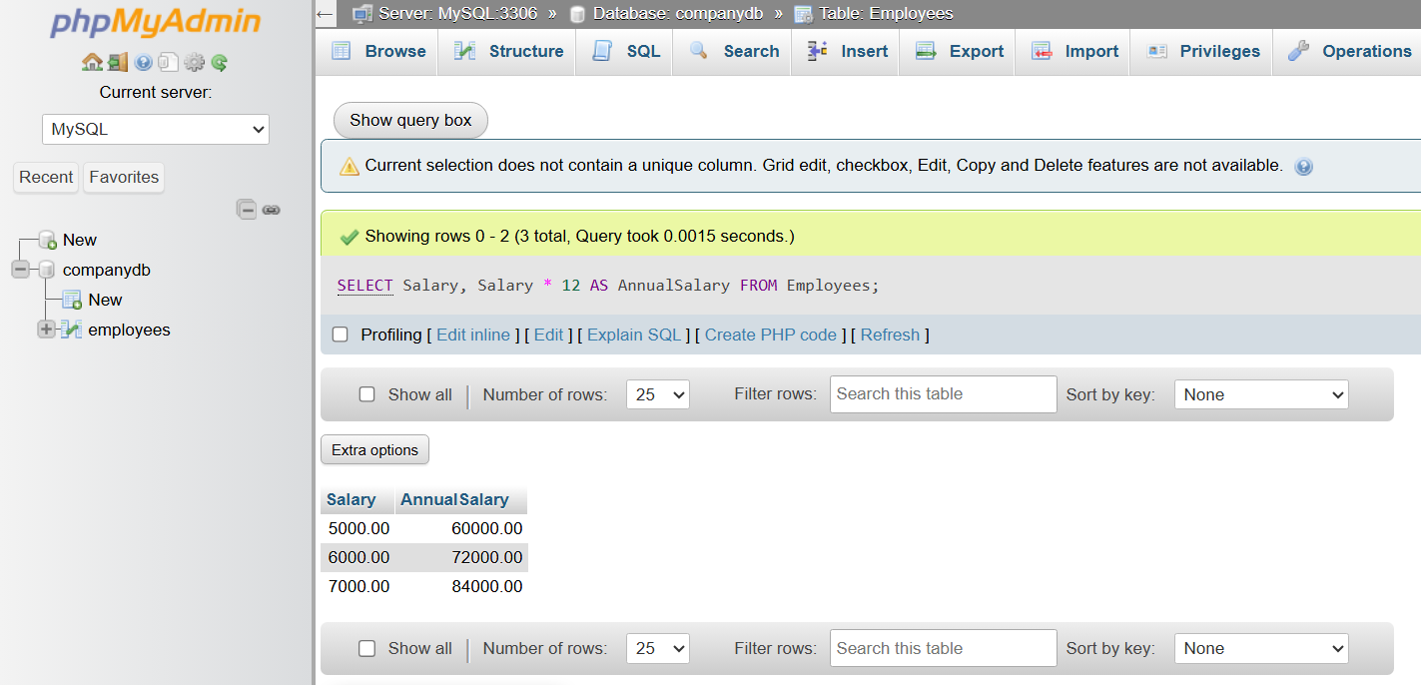

5️⃣ Table Alias
# Source: ScreenShot Source: Provided by: [Persons Table -> ID Column: 1, Name_En Column: Motasem Essam] -> Tool: [Automation Table -> ID Column: 16, Name_En Column: Screen Capture] -> From [Operating System: Wampserver64 -> phpmyadmin] on [6/11/2026]
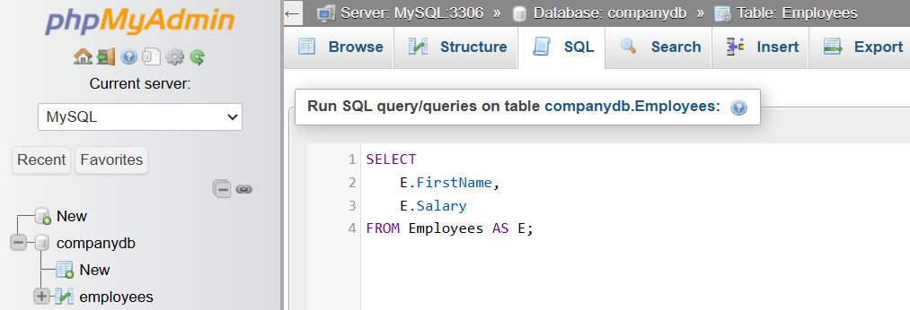
SELECT
E.FirstName,
E.Salary
FROM Employees AS E;
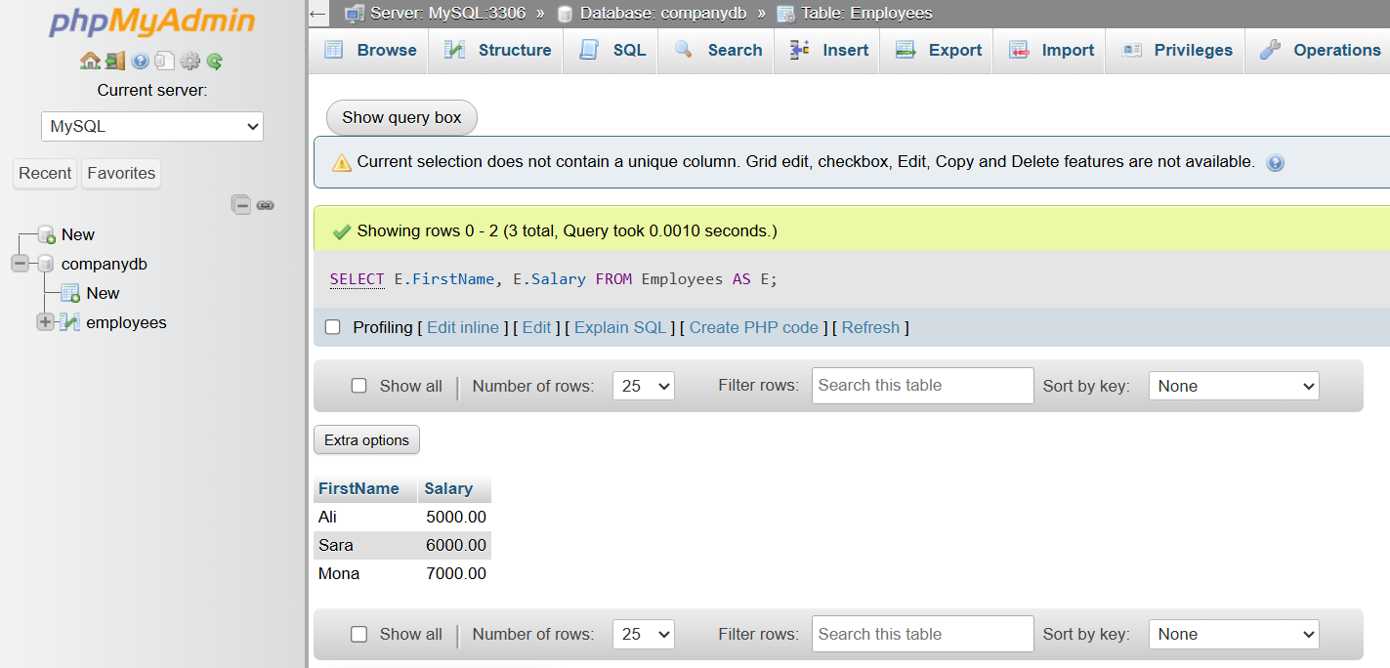

6️⃣ Aggregate Alias
# Source: ScreenShot Source: Provided by: [Persons Table -> ID Column: 1, Name_En Column: Motasem Essam] -> Tool: [Automation Table -> ID Column: 16, Name_En Column: Screen Capture] -> From [Operating System: Wampserver64 -> phpmyadmin] on [6/11/2026]
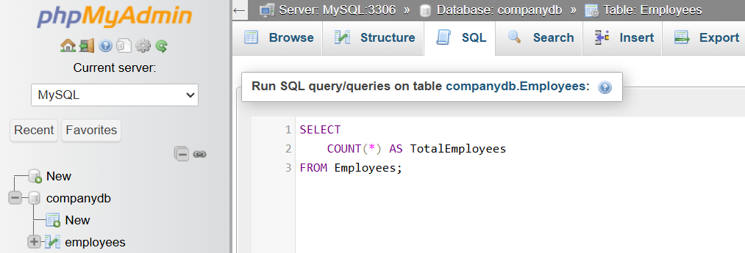
SELECT
COUNT(*) AS TotalEmployees
FROM Employees;
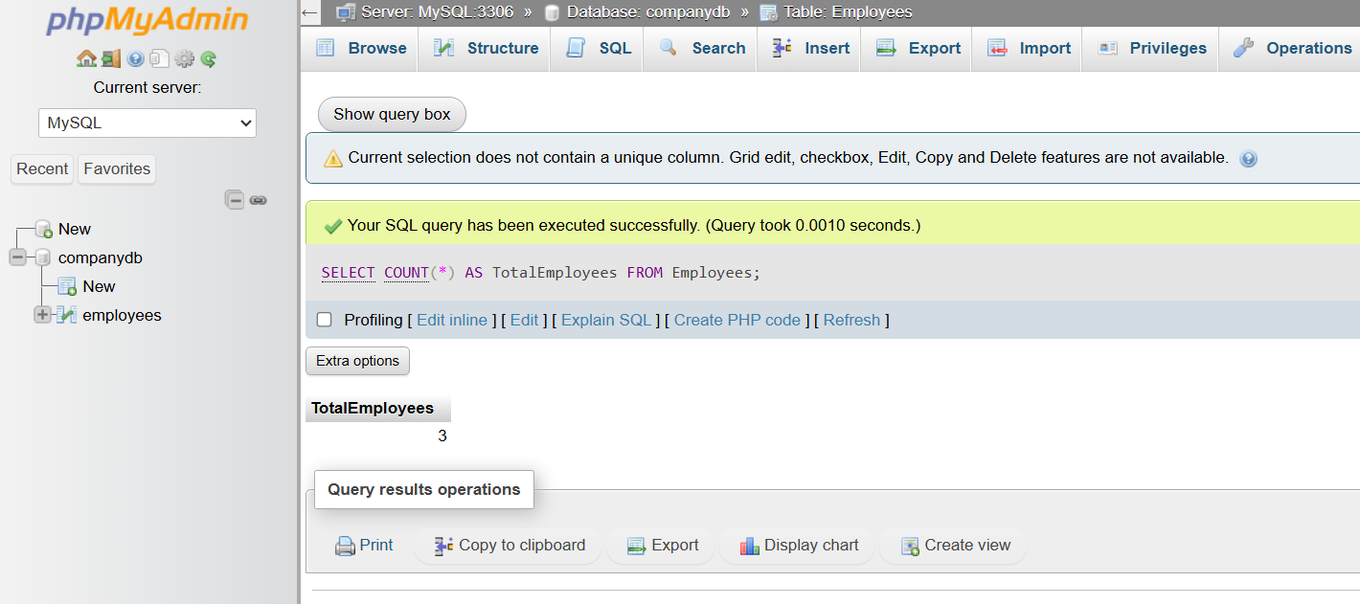

📊 Column Alias vs Table Alias
# Source: AI Source: Provided by: [Data Path: Persons Table -> ID Column: 1, Name_En Column: Motasem Essam] -> From: [ChatGPT] on [6/11/2026]
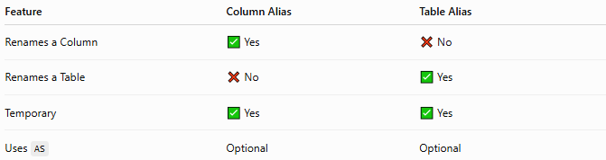
Feature | Column Alias | Table Alias
Renames a Column | ✅ Yes | ❌ No
Renames a Table | ❌ No | ✅ Yes
Temporary | ✅ Yes | ✅ Yes
Uses AS | Optional | Optional

⚠️ Important Notes
# Source: AI Source: Provided by: [Data Path: Persons Table -> ID Column: 1, Name_En Column: Motasem Essam] -> From: [ChatGPT] on [6/11/2026]
- Aliases are temporary and exist only while the query runs.
- The AS keyword is optional in most SQL databases.
- Table aliases are especially useful in JOIN queries.
- Aliases improve readability but do not change the actual table or column names.

🔢 SQL Aliases Workflow
# Source: AI Source: Provided by: [Data Path: Persons Table -> ID Column: 1, Name_En Column: Motasem Essam] -> From: [ChatGPT] on [6/11/2026]
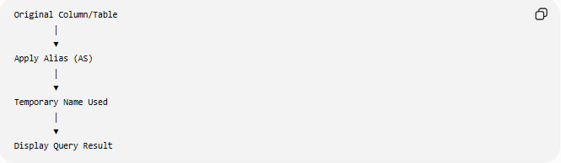
Original Column/Table
│
▼
Apply Alias (AS)
│
▼
Temporary Name Used
│
▼
Display Query Result

🧠 Simple Analogy
# Source: AI Source: Provided by: [Data Path: Persons Table -> ID Column: 1, Name_En Column: Motasem Essam] -> From: [ChatGPT] on [6/11/2026]
Imagine your friend's full name is Alexander Johnson, but everyone calls him Alex.
- Alexander Johnson → Original name
- Alex → Alias (temporary nickname)
Similarly:
- FirstName → Original column
- EmployeeName → Alias used only in the query result
The original column name in the database never changes.

🧭 Summary
# Source: AI Source: Provided by: [Data Path: Persons Table -> ID Column: 1, Name_En Column: Motasem Essam] -> From: [ChatGPT] on [6/11/2026]
SQL Aliases provide temporary names for columns or tables within a query. They improve readability, simplify complex queries, and create meaningful column headings in the output. Aliases are commonly used with SELECT, expressions, aggregate functions, and JOIN statements, and they do not permanently modify the database schema.

